**AIT-524, Class 12, Practice Problems**

**Tanmoy Chowdhury, G01025893**

### Practice Problems: Selected Single-Row Functions

**Questions:**

1. Write an SQL query to display a text string 'your_first_name your_last_name' that represents your full name using the DUAL table.

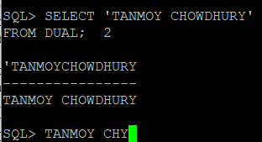

1. Modify the query you created in problem 1. This time, use the INITCAP function to convert characters in the text string 'your_first_name your_last_name' to mixed case.

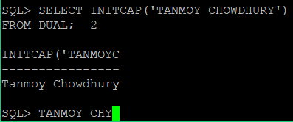

1. Modify the query you created in problem 1. This time, use the INSTR function to determine the position of the single blank space in the text string 'your_first_name your_last_name'.

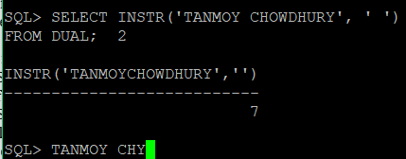

1. Modify the query you created in problem 1. This time, use the SUBSTR function to extract a substring that represents your last name from the text string 'your_first_name your_last_name'. Assume you know the number of characters you need to extract.

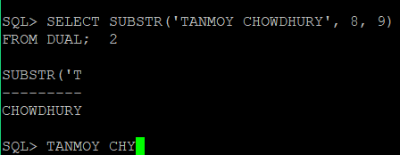

1. Modify the query you created in problem 1. This time, use the INSTR and SUBSTR functions to extract a substring that represents your first name from the text string 'your_first_name your_last_name'. Assume you do not know the number of characters to extract.

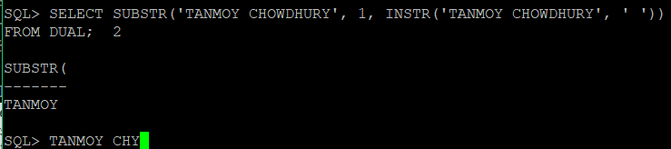

1. Modify the query you created in problem 1. This time, use the INSTR, SUBSTR, and LENGTH functions to extract a substring that represents your last name from the text string 'your_first_name your_last_name'. Assume you do not know the number of characters you need to extract.

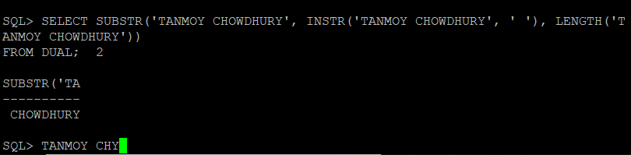

1. Write an SQL query to join three character strings: your first name, blank space, and your last name. Use a nested CONCAT function and the DUAL table.

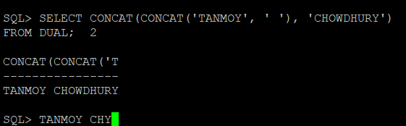

1. Write an SQL query to calculate the number of months until Christmas. Use the MONTHS_BETWEEN function and the DUAL table. Then, round off the answer to an integer. Decide which function - ROUND or TRANC - to be used for rounding off. Explain your reasoning.

**Explanation:** I tried to truncate the numeric value to a specific position, That’s why used TRANC function.

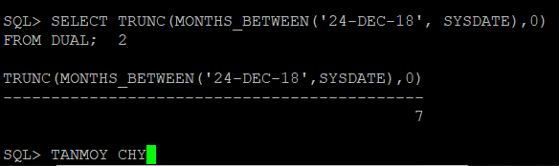

1. Write an SQL query to display a text string 'JANUARY 21, 2013' as a date using the TO_DATE function and the DUAL table. (Hint: correct format model to use for this string is 'MONTH DD, YYYY').

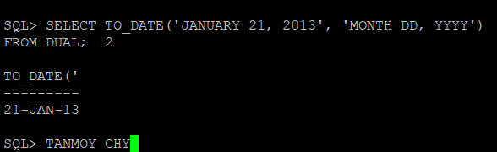

1. Write an SQL query to display a date '21-JAN-13' as a text string using the TO_CHAR function and the DUAL table. You may use any format model that is different from the default Oracle date format.

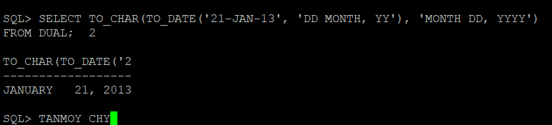

### Practice Problems:  Group Functions

**Questions:**

1. Calculate the average value, the maximum value, and the minimum value for one of the columns in the JustLee Books Database using the AVG, MAX and MIN group functions.

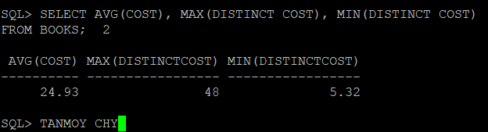

1. Use the COUNT function to count non-NULL values first and then to count the total number of records in one of the tables in JustLee Books Database.

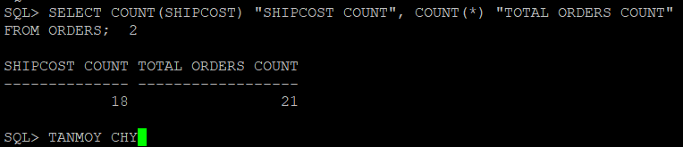

1. Write an SQL query that uses the GROUP BY, WHERE and HAVING statements. Explain what the query is supposed to do.

**Explanation:** This query will choose all the orders later than 01-Jan-01 and then grouped them based on their orderdate whose average shipping cost is greater than 0.

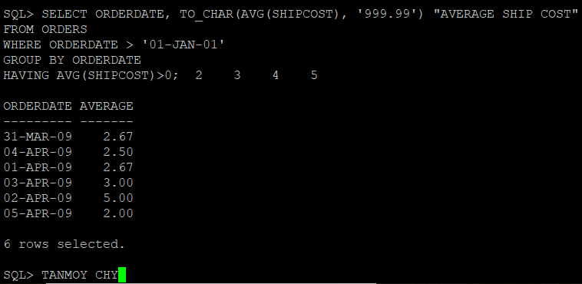

1. Write an SQL query that uses the GROUP BY ROLL statement. Explain what the query is supposed to do.

**Explanation:** This query will choose all the orders later than 01-Jan-01 and then after grouped them based on their orderdate and shipdate. Then make the average and choose whose average shipping cost is greater than 0.

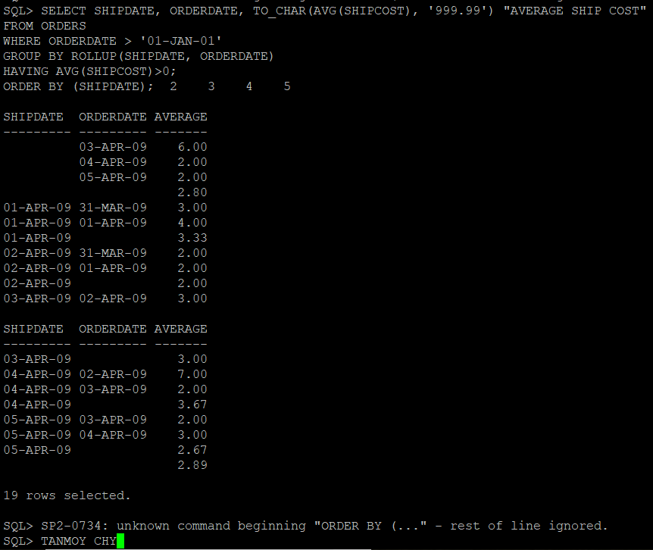

1. Write an SQL query that uses the GROUP BY CUBE statement. Explain what the query is supposed to do.

**Explanation:** This query will choose all the orders later than 01-Jan-01 and then after grouped them based on their orderdate, orderdate and shipdate. Then make the average and choose whose average shipping cost is greater than 0.

